

A MINI PROJECT REPORT

On

WRITE YOUR PROJECT TITLE HERE WITH THE SAME FONT

Submitted in partial fulfillment of the requirement of University of Mumbai for the Course

**In**

# Computer Engineering (IV SEM)

Submitted By

**Aditya Yadav**

**Shauryan Singh**

**Viraj Jadhav**

Subject In-charge

**Subject In-charge Name**

(Merlin Priya Jacob)



**CERTIFICATE**

This is to certify that the requirements for the project report entitled ‘**Project Title**’ have been successfully completed by the following students:

|  |  |
| --- | --- |
| **Name** | **Moodle Id** |
| Aditya Yadav | 19102006 |
| Shauryan Singh | 19102004 |
| Viraj Jadhav | 19102022 |

In partial fulfilment of the course **Python Programming (MEL 403)**\* in Sem: IV of Mumbai University in the Department of Computer Engineering during academic year 2020-2021.

Sub-in-Charge

# 

# PROJECT APPROVAL

The project entitled ‘**Project Title**’ by **Aditya Yadav, Shauryan Singh and Viraj Jadhav** are approved for the course of **Python Programming (MEL 403)**\* in Sem: IV of Mumbai University in the Department of Computer Engineering.

Subject-in-Charge

Date:

Place: Thane

**Table of Contents**

|  |  |  |
| --- | --- | --- |
| **Sr**. **No.** | **Topic** | **Page No.** |
| 1. | Abstract (150-200 words) --- **DONE** |  |
| 2. | List of Figures |  |
| 3. | List of Tables |  |
| 4. | Problem Definition --- **DONE** |  |
| 5. | Introduction --- **DONE** |  |
| 6. | Description of the modules used --- **DONE** |  |
| 7. | Implementation details with screen-shots --- **DONE** |  |
| 8. | Conclusion and Future Scope |  |
| 9. | References |  |
| 10. | Acknowledgement --- **DONE** |  |

**FOLLOW THE GUIDELINES GIVEN BELOW FOR PREPARING DOCUMENT IN THE GIVEN FORMAT**

1. The project report should be neatly typed.
2. Avoid using Abbreviations.
3. The text should be justified and typed in the Font style ‘Times New Roman’ and Font size ‘12’.
4. Heading and subheading should be bold with font 14.
5. As of now only prepare soft copy of the document.
6. Report should be of 15-20 pages

**Abstract**

This project is based on the concept of making a *Quiz App* using Python. With the help of python’s in-built packages,we were able to portray this project in a Graphical User Interface, wherein the user has to fill in the required details, play quiz and, in the end, the score will be displayed. So, this will be an efficient and online mode of conducting the quiz. The main objective of this project is to efficiently evaluate the candidate thoroughly through a fully automated system that not only saves lot of time but also gives fast results. Candidate details and scores are stored in the database and can be fetched from the server. If the candidate is already registered in the database, then only the score will be updated rest all the data is kept constant. So, there won’t be any ambiguity. The system carries out the examination and auto-grading for multiple choice questions which is fed into the system.

**List of Figures**

**List of Tables**

**Problem Definition**

For this mini-project, we aim to develop a *Quiz App* wherein the candidate will be allowed to play a quiz game for a particular set of questions and will be marked based upon the correctness in answer. This data will be stored in the database and, if in case the same candidate is playing the game again, then only the new high score will be updated so that memory is used feasibly. The quiz will be a multiple-choice question with four options.

**Introduction**

A Quiz is a very important part of education and content revising. So, with the help of Python, we have designed a graphical user interface to allow the interested candidates to give quizzes and view their results. It is cost as well as time effective. The main aim of this project is to facilitate a user-friendly environment.

At first, a candidate will have to register themself through proposed system by entering some basic personal details like name, email id, contact number and, stream. From this inputted data, the name will be stored in the database. Once the quiz is finished there will be a score prompt in which the score of candidates with his name will be displayed. This score is now stored in the database. If a registered candidate is playing the game then only the high score will be stored.

**Description of Modules Used:**

1. **Tkinter:** The tkinter package is the standard Python interface to the Tk GUI toolkit. It is a cross platform library.
2. **Ttk:** The tkinter.ttk module provides access to the Tk themed widget set. The basic idea for tkinter.ttk is to separate, to the extent possible, the code implementing a widget’s behavior from the code implementing its appearance. Some widgets used in our program are Frame, Message box, Radio buttons, Buttons and Labels.
3. **Message box:** The tkinter. message box, module provides a template base class as well as a variety of convenience methods for commonly used configurations. The message boxes are modal and will return a subset of (True, False, OK, None, Yes, No) based on the user’s selection.
4. **Random:** This module implements pseudo-random number generators for various distributions. For integers, there is uniform selection from a range. For sequences, there is uniform selection of a random element, a function to generate a random permutation of a list in-place, and a function for random sampling without replacement.
5. **SQLite 3:** SQLite is a C library that provides a lightweight disk-based database that doesn’t require a separate server process and allows accessing the database using a nonstandard variant of the SQL query language. Some applications can use SQLite for internal data storage. It’s also possible to prototype an application using SQLite and then port the code to a larger database such as PostgreSQL or Oracle.

**Implementation Details**

Fig 1.1

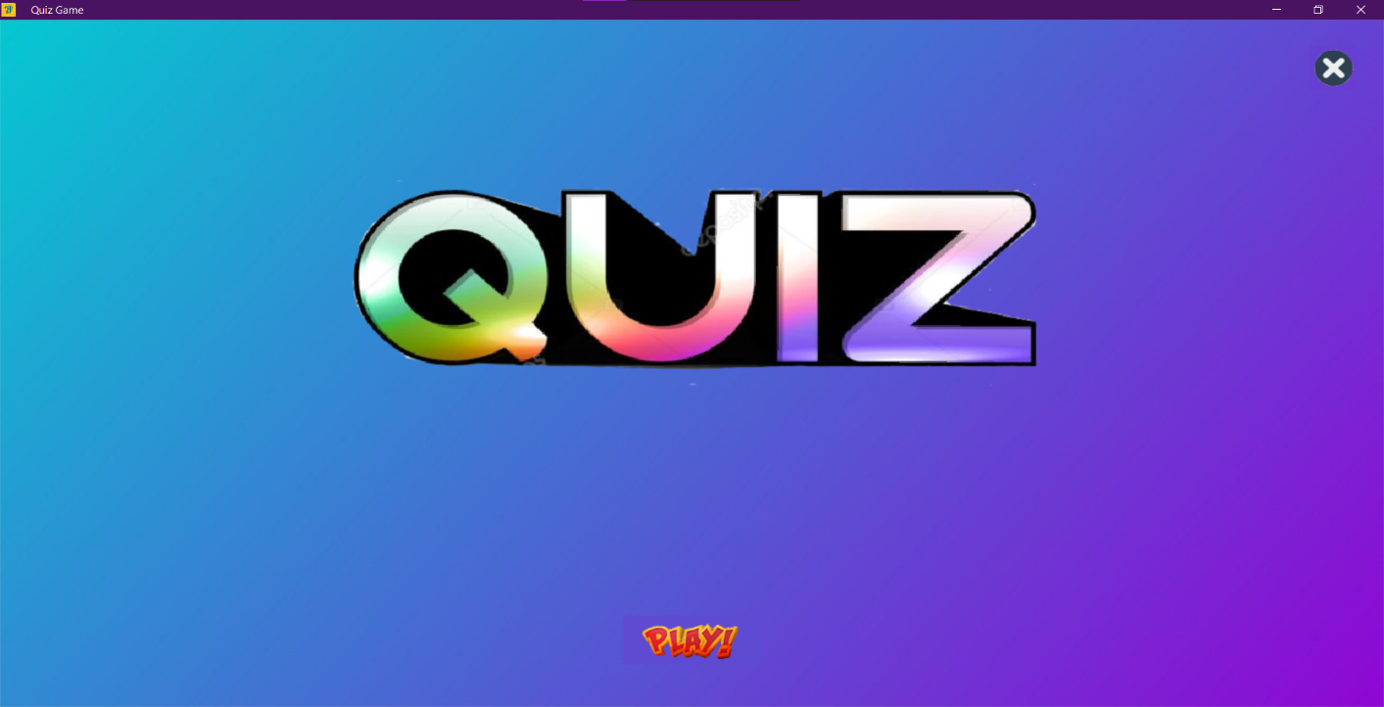

Fig 1.2

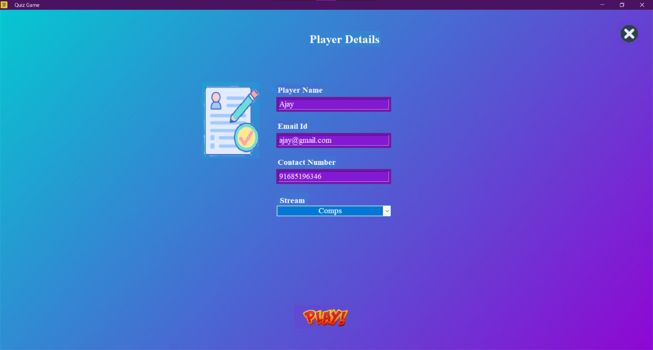

Fig 1.3

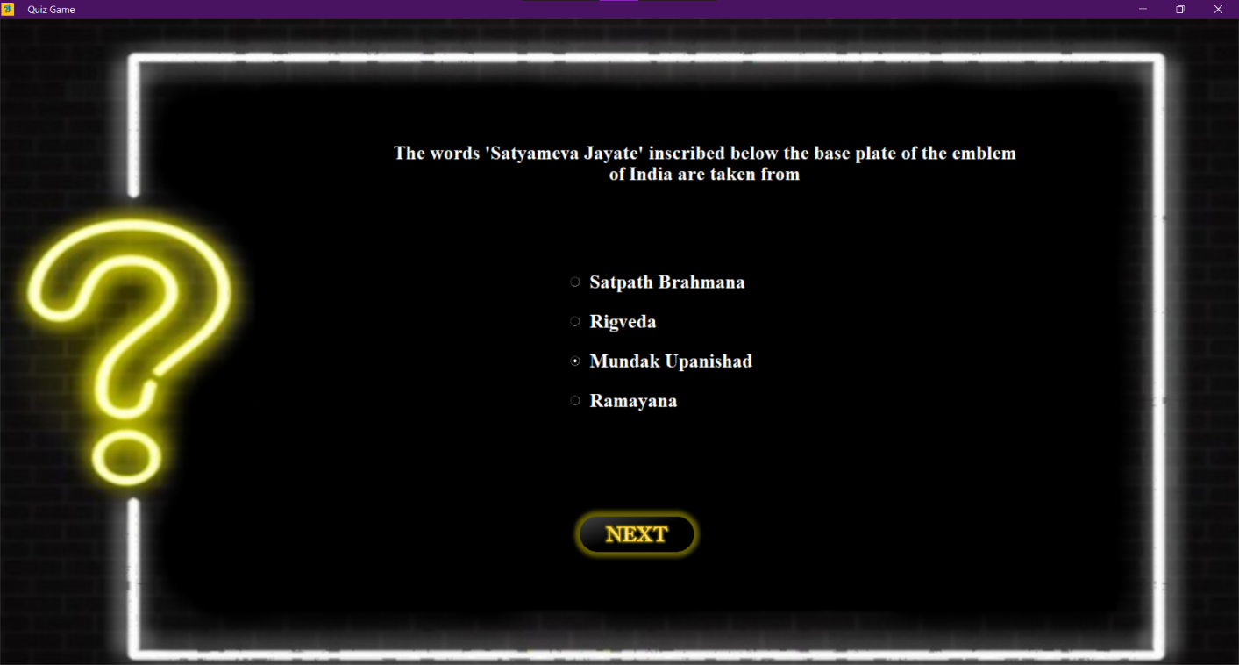

Fig 1.4

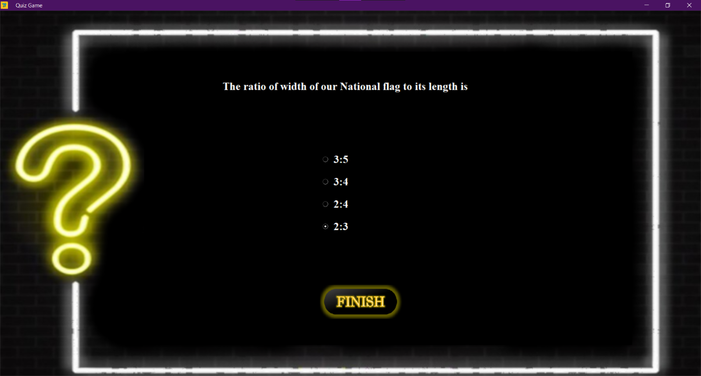

Fig 1.5

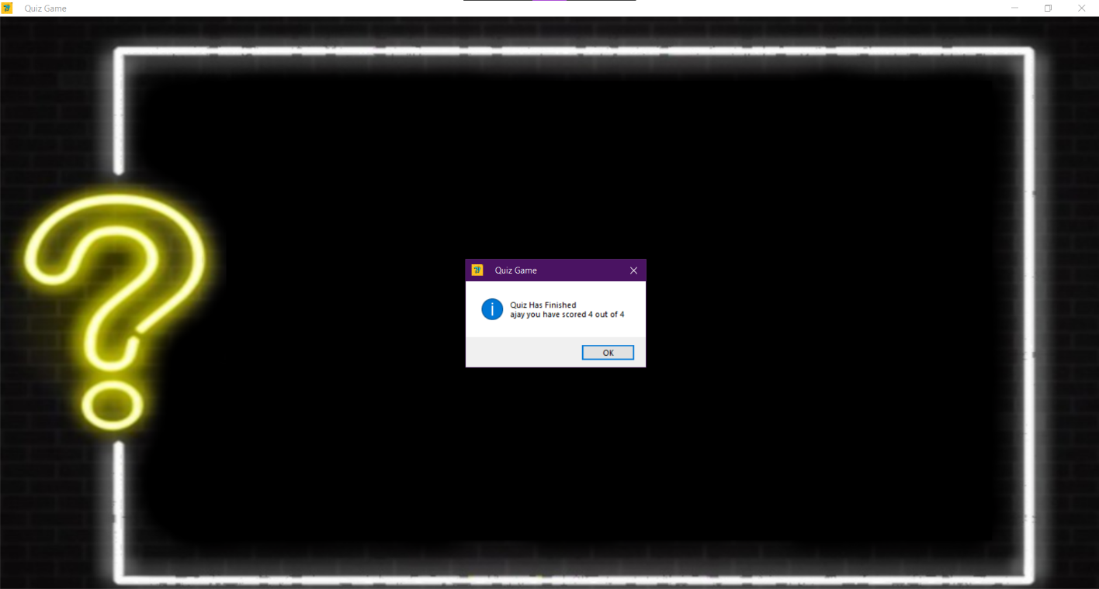

Fig 1.6

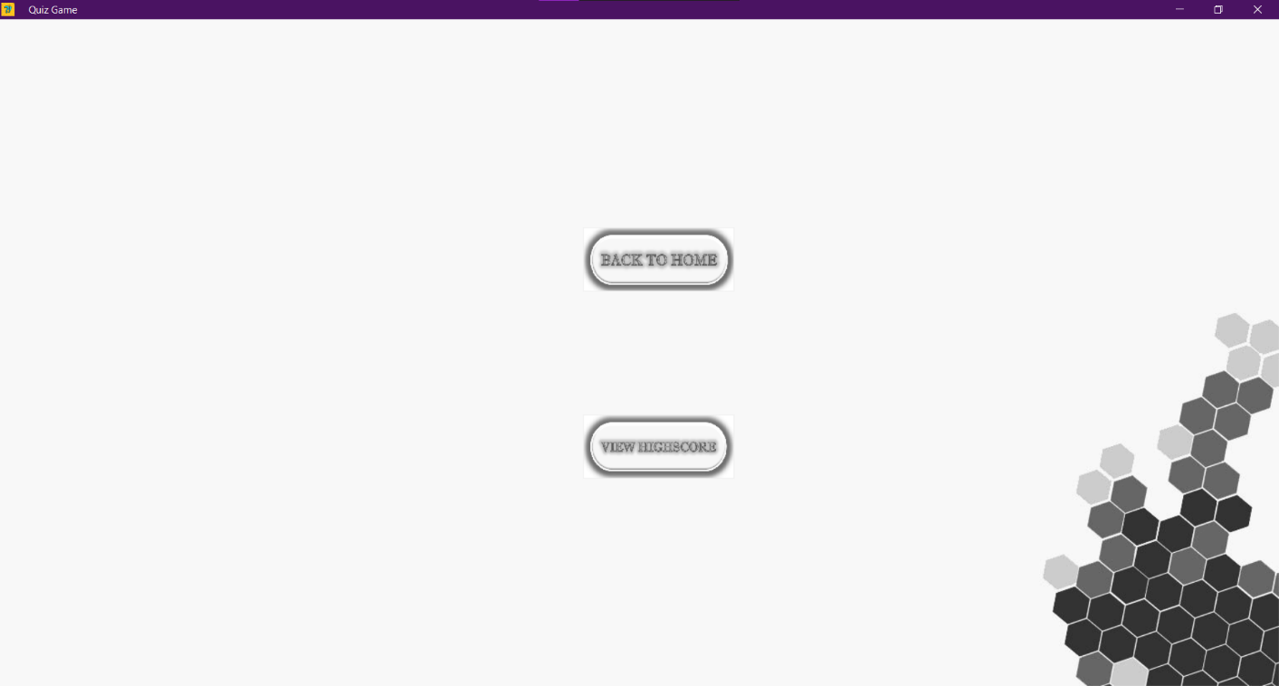

Fig 1.7

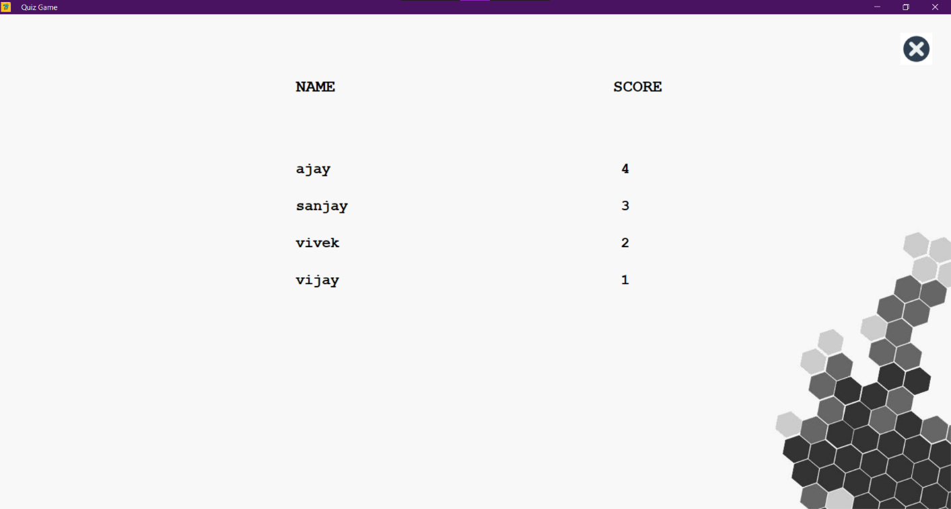

**ACKNOWLEDGEMENT**

We have the great pleasure in presenting the mini-project report on Quiz App. We would like to express our sincere regard and indebtedness to our project guide Merlin Priya Jacob, Department of Computer Engineering, APSIT Thane for her valuable time, guidance, encouragement, support and cooperation throughout the duration of our project. We would sincerely like to thank Computer Department for giving us the opportunity to work on enhancing our technical skills while undergoing this project. This project helped us in understanding the various parameters which are involved in the development of our project.

We thank Prof. Sachin Malave, Head of Department, Computer Engineering, APSIT for his encouragement during progress meeting and providing guidelines to write this report.

We also thank the entire staff of APSIT for their invaluable help rendered during the course of this work. We wish to express our deep gratitude towards all our colleagues of APSIT for their encouragement.

Student Name 1: Aditya Yadav

Moodle Id: 19102006

Student Name 2: Shauryan Singh

Moodle Id: 19102004

Student Name 3: Viraj Jadhav

Moodle Id: 19102022